D. UNINSTALL AND REINSTALL OF RESIDENT MANAGER PROGRAM

From time to time, for various reasons, a software program may experience problems or be corrupted. If you should experience a problem with your Resident Manager Program and need to reinstall a clean version, follow these steps:

- Backup your current resident database information -

From the Database Utilities menu in Resident Manager, click on “Backup” to create a backup of your resident database.

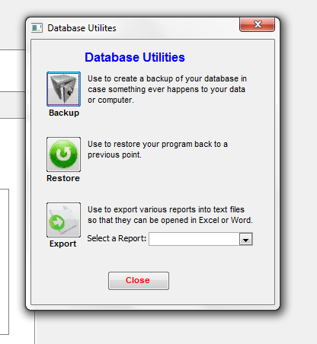

(*This enables you to save a copy of your resident information to date. Then once you have reloaded the software, you can upload the backup of your resident information back into the program rather than needing to re-input all that information.)

To ensure that you have a good database that you can use later to upload back into the clean version of the program, it is suggested that you back up the information to two separate places. For example, save one copy somewhere on your hard drive or desktop and save another copy to a jump drive.

- Uninstall the Resident Manager File from your computer -

First, locate the Resident Manager file where it is installed on your computer. (*This is a file folder. You are not going into the software application.) This folder should be saved as a shortcut icon on your desktop, labeled something like “RM 4.2.1.” Click on this shortcut icon.

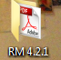

***If there is not a shortcut icon on your desktop, see if you can locate the Resident Manager file folder in your computer’s program file lists. Click on “Start”, then “Computer,” then look in the drive where you store your programs. This will be your hard drive, i.e. “Local Disk (C:)” or it could be a network drive that your company uses, i.e. (D:), (F:), or whatever drive is designated by your company as its network drive. Click on that drive and locate the “RM 4.2.1” file folder. IF YOU DO NOT HAVE A RESIDENT MANAGER FILE FOLDER SHORTCUT ICON ON YOUR DESKTOP AND ARE UNABLE TO LOCATE IT ON YOUR COMPUTER, CONTACT INNOVATIONS SERVICES TO HAVE THE FILE FOLDER SENT TO YOU.***

Once you are in the “RM 4.2.1” File Folder, select “Utilities.”

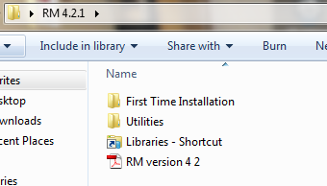

Under “Utilities” will be an application file titled “WindowsInstallerCleanup.” Double click on that file and run through the process, hitting “Next,” “I Accept License Agreement,” “Next” and when the process is done hit “Finish.” This installs the cleanup file on your computer.

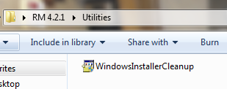

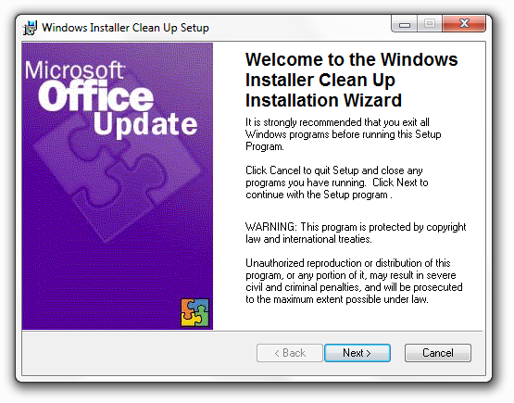

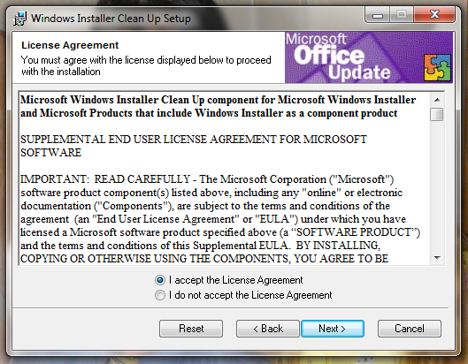

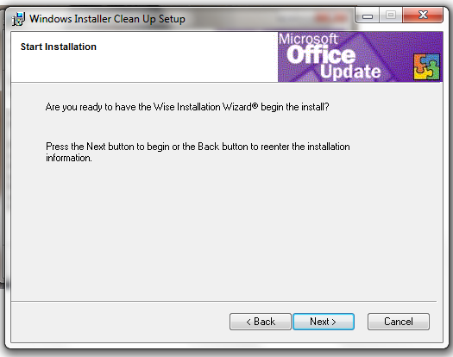

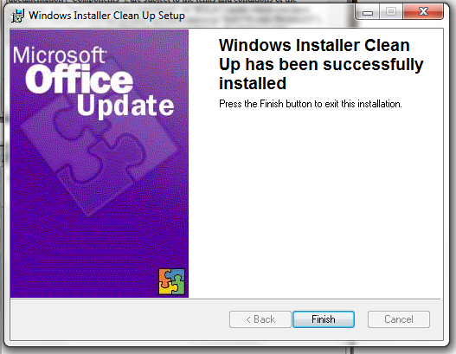

Now that the cleanup file is loaded onto your computer, go back into the “Startup” menu and select “All Programs.” From the list of programs, double click on “Windows Install Cleanup.” This will bring up a list of programs. Scroll through the list to locate the “Resident Mgr v4.2.1” file and click on it to highlight it. Then select “Remove.” This will remove the program from your system. (*The only exception to the file name would be if a newer version were installed on your system, i.e. if not “Resident Mgr v4.2.1, it may be Resident Mgr v4.2.2 or v4.3.1, etc.*)

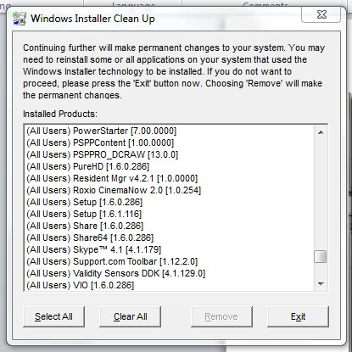

***If there are any icons to Resident Manager left on your computer, delete them at this time. They are no longer valid icons. A new icon will be put onto your system when you complete the reinstall.***

To remove the Windows Installer Clean Up Program from your system, simply go back into the “RM 4.2.1” File Folder, and again select “Utilities,”

And rerun “WindowsInstallerCleanup.” This process will be two steps and will remove that program from your computer.

- Reinstall the Resident Manager program to your computer -

Refer to Sections A, B and C of the Getting Started with Resident Menu Manager and Resident Manager document to reinstall the Resident Manager Program and restore your resident information database back into the Program.

